# **Win Prizes By Pledging to Drive Less with IE Commuter This Earth Day**

This Earth Day, commit to making a positive impact on the planet with the IE Commuter "Drive Less, Smile More" pledge to make your commute even more rewarding! By reducing your drive-alone commute, you’ll not only lower your carbon footprint but also increase your chances to win exciting prizes throughout April.

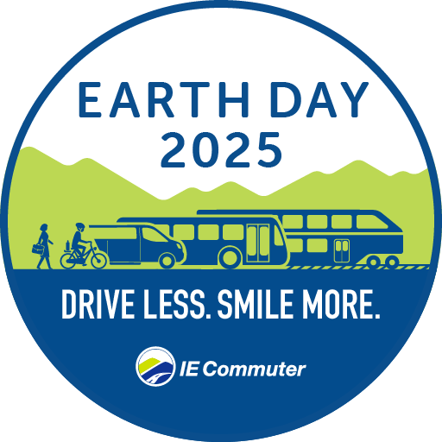Once you’ve signed the pledge, log your rideshare trips and telework days with IE Commuter all April long for a chance to win prizes including an Apple iPad, Nintendo Switch Lite, Dana Wharf Whale Watching Tickets, or gift cards to Macy’s or Starbucks. You’ll be entered by taking the pledge, then each trip you log gives you an additional chance to win. The more you reduce your drive-alone commute, the better your chances of scoring a great prize!

Ready to make a difference? Visit IECommuter.org/EarthDay to take the pledge and for more information including a full list of prizes. Chat with the IE Commuter team at IECommuter.org or call 1-866-RIDESHARE (866-743-3742) with any questions.